Coughing and Sneezing
Covering coughs and sneezes and keeping hands clean can help prevent the spread of serious respiratory illnesses like influenza, respiratory syncytial virus (RSV), whooping cough, and COVID-19. Germs can be easily spread by:
- Coughing, sneezing, or talking.
- Touching your face with unwashed hands after touching contaminated surfaces or objects
- Touching surfaces or objects that may be frequently touched by other people.
To help stop the spread of germs:
- Cover your mouth and nose with a tissue when you cough or sneeze.
- Throw used tissues in the trash.
- If you don’t have a tissue, cough, or sneeze into your elbow, not your hands.
Remember to immediately wash your hands after blowing your nose, coughing or sneezing.
Washing your hands is one of the most effective ways to prevent yourself and your loved ones from getting sick, especially at key times when you are likely to get and spread germs.
- Wash your hands with soap and water for at least 20 seconds
- If soap and water are not readily available, use an alcohol-based hand sanitizer that contains at least 60% alcohol to clean hands
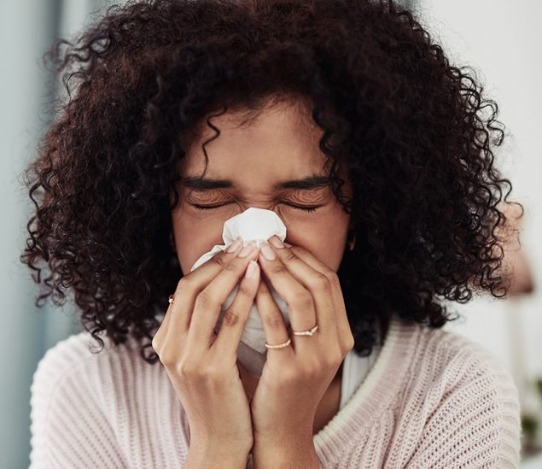
Teach patients how to cover their coughs and sneezes.
For information about preventing the spread of COVID-19, see CDC’s COVID-19: Prevent Getting Sick web page.
To help prevent the spread of respiratory disease, you can also avoid close contact with people who are sick. If you are ill, you should try to distance yourself from others, so you do not spread your germs. Distancing includes staying home from work or school when possible.

